Project Design Phase-II
Data Flow Diagram & User Stories

Date | 08-03-2026
Team ID | SWTID-2026-3933
Project Name | LIB SPACE
Maximum Marks | 4 Marks

Data Flow Diagrams (DFD)
A Data Flow Diagram (DFD) is a visual tool used to illustrate how information moves through a system. It helps represent system processes in a clear and structured way. A well-designed DFD visually explains the system requirements by showing how data enters the system, how it is processed, where it is stored, and how it leaves the system.
DFDs make it easier to understand how different parts of a system interact with data and how information flows between users, processes, and storage components.
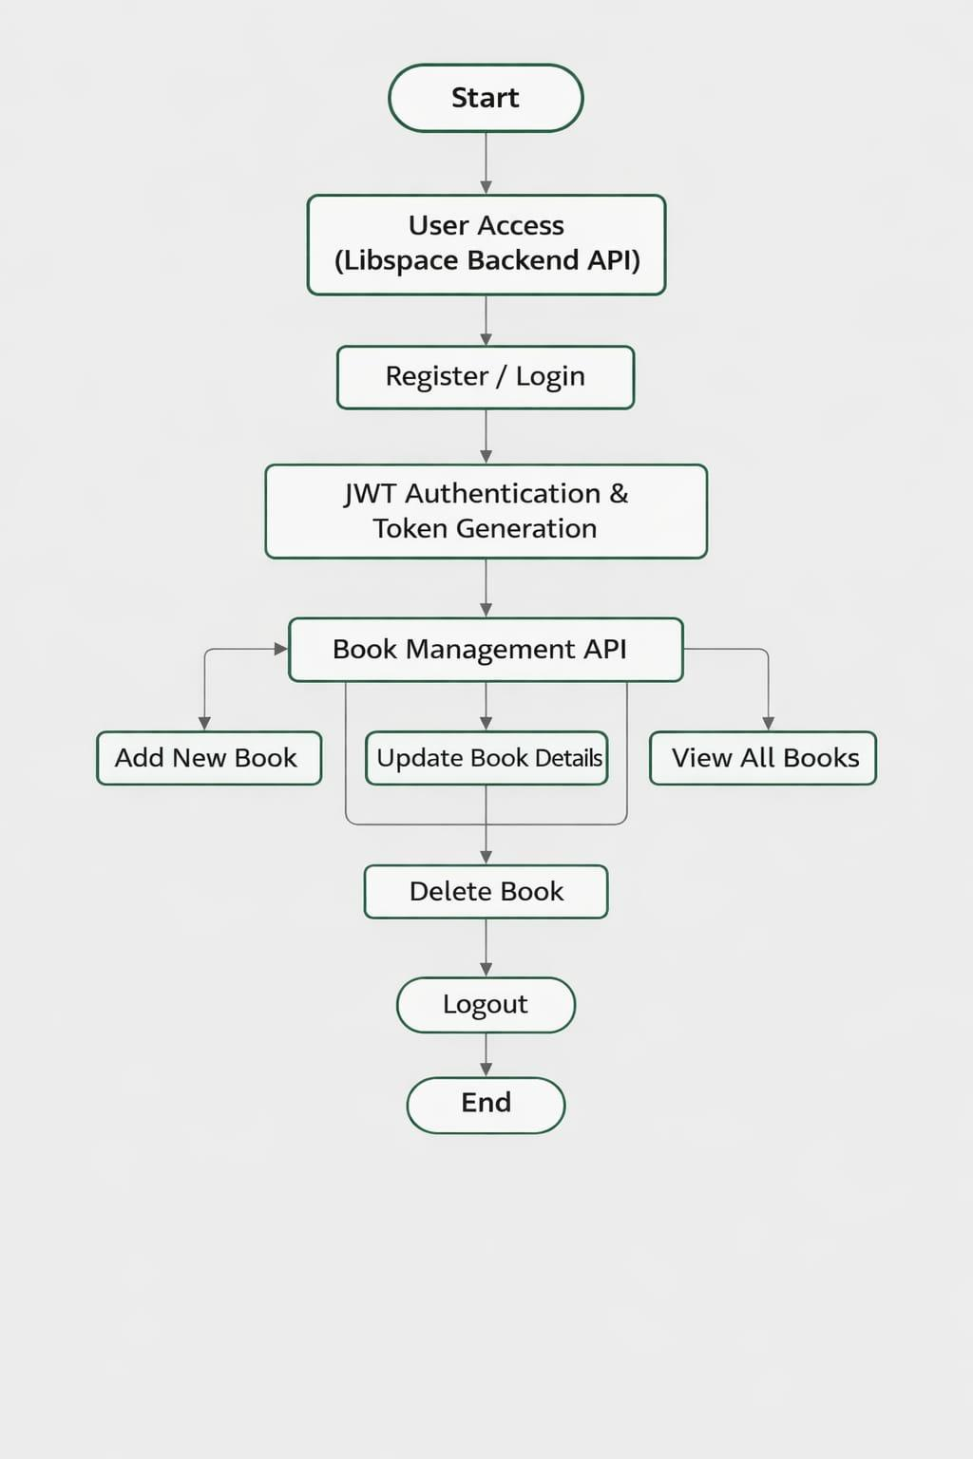

User Stories
Use the below template to list all the user stories for the product.
User Type | User Story Number | User Story / Task | Acceptance criteria | Priority | Release
Customer  (Web user) | USN-1 | As a user, I want to sign up using my email and password so that I can create a personal account. . | The system should securely store user information in the database, and the password must be encrypted using bcrypt. | High | Sprint-1
Customer  (Web user) | USN-2 | As a user, I want to log in with my registered email and password to access my account. | When login is successful, a JWT token should be created and the user should be allowed to access protected routes. | High | Sprint-1
Customer  (Web user) | USN-3 | As a user, I want the ability to add a new book to my account for personal management. | The book information should be stored in the database and associated with the currently logged-in user. | Low | Sprint-2

